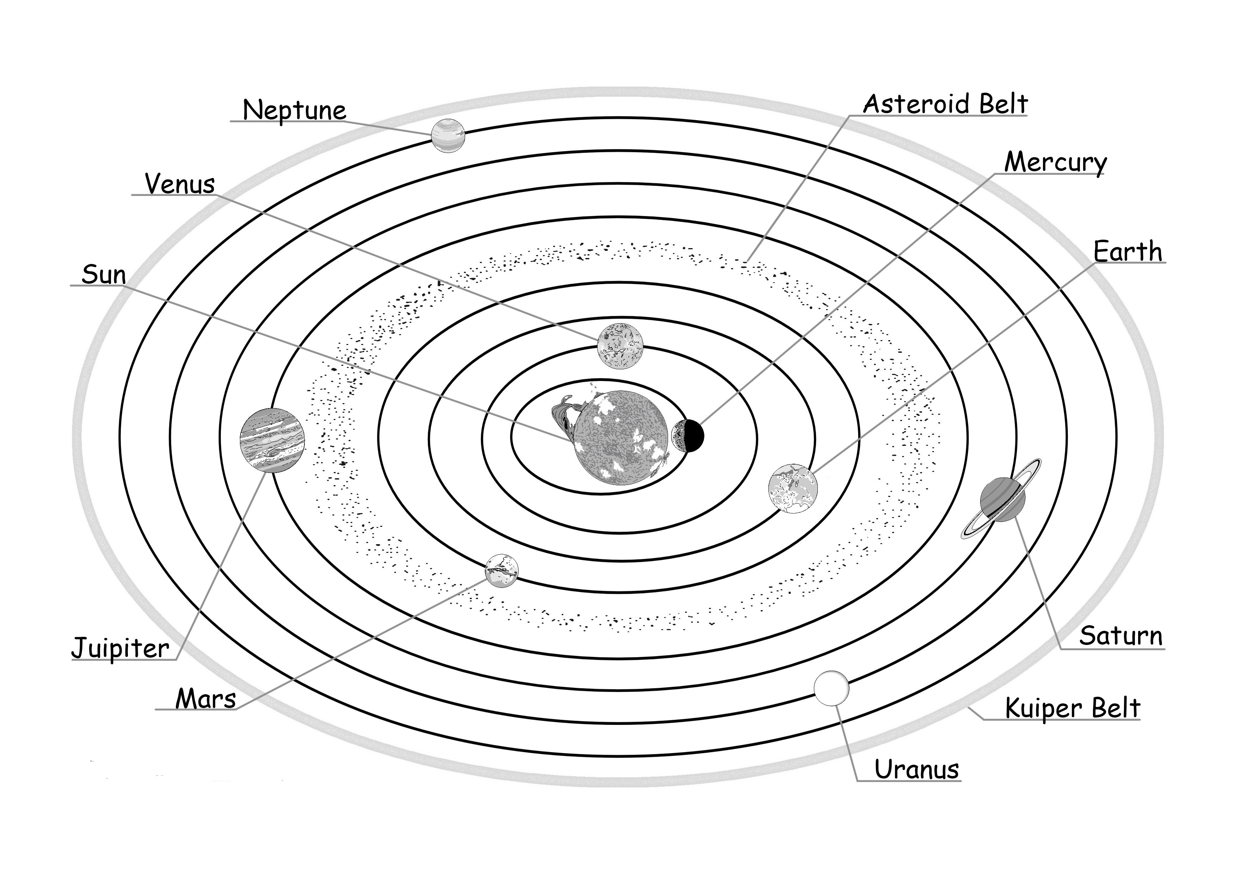
WEBQUEST: THE SOLAR SYSTEM

THE PLANET

Go to our web and click on the picture of your planet.

1. List three important facts about this planet that you read from the title page.

A. _______________________________________________

B. _______________________________________________

C. _______________________________________________

Click on Planetary Facts to answer the following:

A. Diameter: _______________

B. Rotation period: _______________

C.Distance from the Sun: _______________

D. Number of satellites/rings: _______________

Click on the Back button and then answer the question.

__________________________________________________________________

Click on the Back button and write down an amazing fact of the planet. Did you know?

_________________________________________________________________

__________________________________________________________________

